"1973-01-31::2006-12-31"

Buy & Hold GTAA

Return 11.27 11.60

Volatility 8.92 6.90

Sharpe 0.53 0.74

MaxDD -19.61 -9.56

Inflation CAGR 4.71 4.71

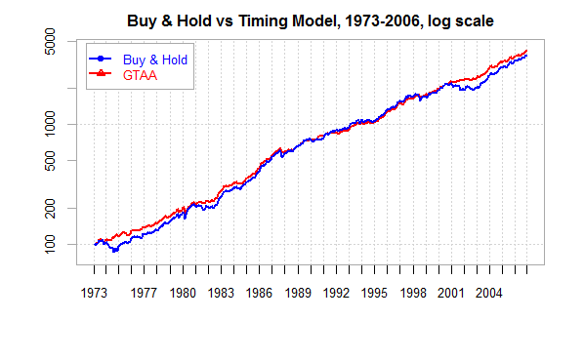

"2006-12-31::2016-12-31"

Buy & Hold GTAA

Return 2.54 3.90

Volatility 13.18 6.53

Sharpe 0.14 0.48

MaxDD -46.10 -9.22

Inflation CAGR 1.85 1.85

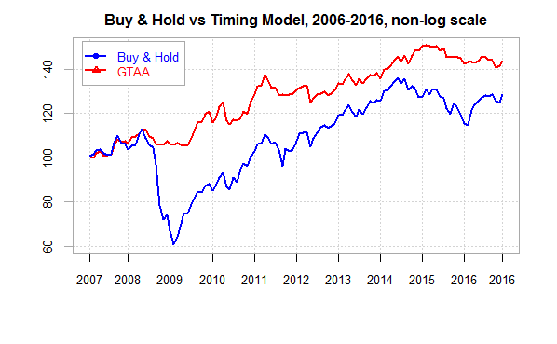

"1973-01-31::2016-12-31"

Buy & Hold GTAA

Return 9.25 9.80

Volatility 10.09 6.87

Sharpe 0.41 0.68

MaxDD -46.10 -9.56

Inflation CAGR 4.04 4.04

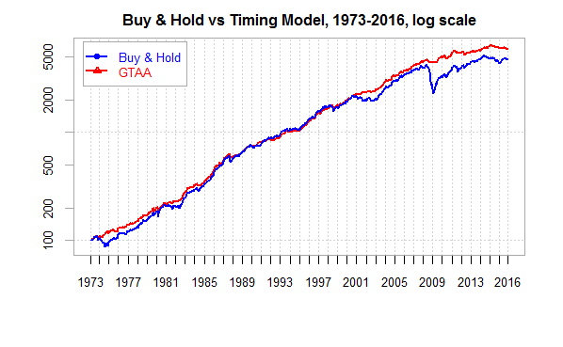

With / without commodities!

####Performance Charts

```{r}

SubsetPeriod <- "1973-01-31::2016-12-31"

Returns <- cbind.xts(TimingModelCalcs.xts$BUYANDHOLD.ret,TimingModelCalcs.xts$GTAA.ret)[SubsetPeriod]

CumReturns <- 100\*cumprod(1+Returns[-1,])

colnames(CumReturns) <- c("Buy & Hold","GTAA")

chart.TimeSeries(CumReturns["1973-01-31::2006-12-31"],

main = "Buy & Hold vs Timing Model, 1973-2006, log scale",

date.format = "%Y",

colorset = c(4,2),

ylab = "",

ylog = TRUE,

ylim = c(80,4400),

legend.loc = "topleft",

major.ticks = "years",

minor.ticks = FALSE)

chart.TimeSeries(CumReturns["1973-01-31::2016-12-31"],

main = "Buy & Hold vs Timing Model, 1973-2006, log scale",

date.format = "%Y",

colorset = c(4,2),

ylab = "",

ylog = TRUE,

#ylim = c(80,4400),

legend.loc = "topleft",

major.ticks = "years",

minor.ticks = FALSE)

SubsetPeriod <- "2007-01-31::2016-12-31"

Returns <- cbind.xts(TimingModelCalcs.xts$BUYANDHOLD.ret,TimingModelCalcs.xts$GTAA.ret)[SubsetPeriod]

CumReturns <- 100\*cumprod(1+Returns[-1,])

colnames(CumReturns) <- c("Buy & Hold","GTAA")

chart.TimeSeries(CumReturns,

main = "Buy & Hold vs Timing Model, 2006-2016, non-log scale",

date.format = "%Y",

colorset = c(4,2),

ylab = "",

ylog = FALSE,

#ylim = c(80,240),

legend.loc = "topleft",

major.ticks = "years",

minor.ticks = FALSE)

```

```{r}

SubsetPeriod <- "2006-12-31::2016-12-31"

Rf.ret <- Return.calculate(TBILLS)[-1,]

Rf.ret <- Rf.ret[SubsetPeriod]

Returns <- cbind.xts(TimingModelCalcs.xts$BUYANDHOLD.ret,TimingModelCalcs.xts$GTAA.ret)[SubsetPeriod]

stats <- rbind(100\*Return.annualized(Returns,scale = 12),

100\*StdDev.annualized(Returns,scale = 12),

SharpeRatio.annualized(Returns,Rf = Rf.ret$TBILLS.Close),

100\*maxDrawdown(Returns,invert = FALSE),

100\*c(Return.annualized(Return.calculate(Cl(CPI))[SubsetPeriod],scale = 12))

)

colnames(stats) <- c("Buy & Hold","GTAA")

rownames(stats) <- c("Return","Volatility","Sharpe","MaxDD","Inflation CAGR")

round(stats,2)

write.table(round(stats,4), "clipboard", sep="\t", col.names=NA)

```